Chart Patterns:

AAPL(NASDAQ)

Ascending Triangle

Timestamp- 15-06-2023 19:40pm

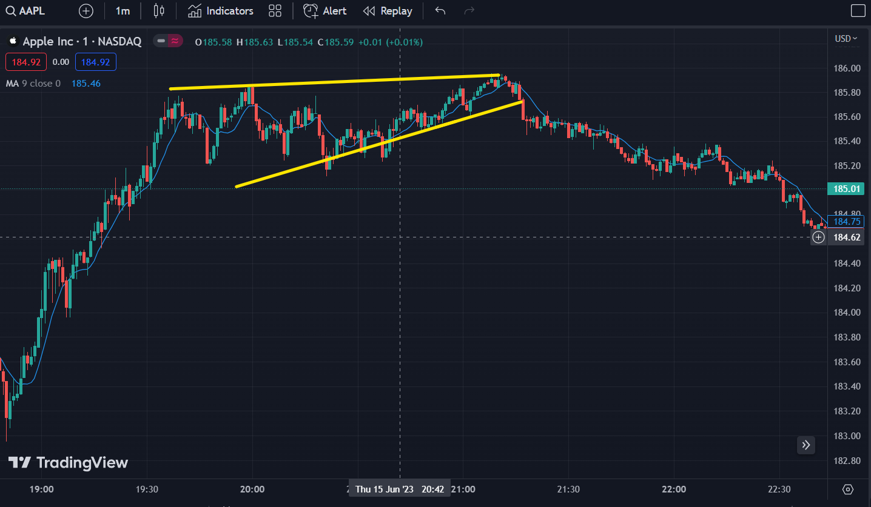

Bearish Flag

Timestamp- 31-05-2023 19:30pm

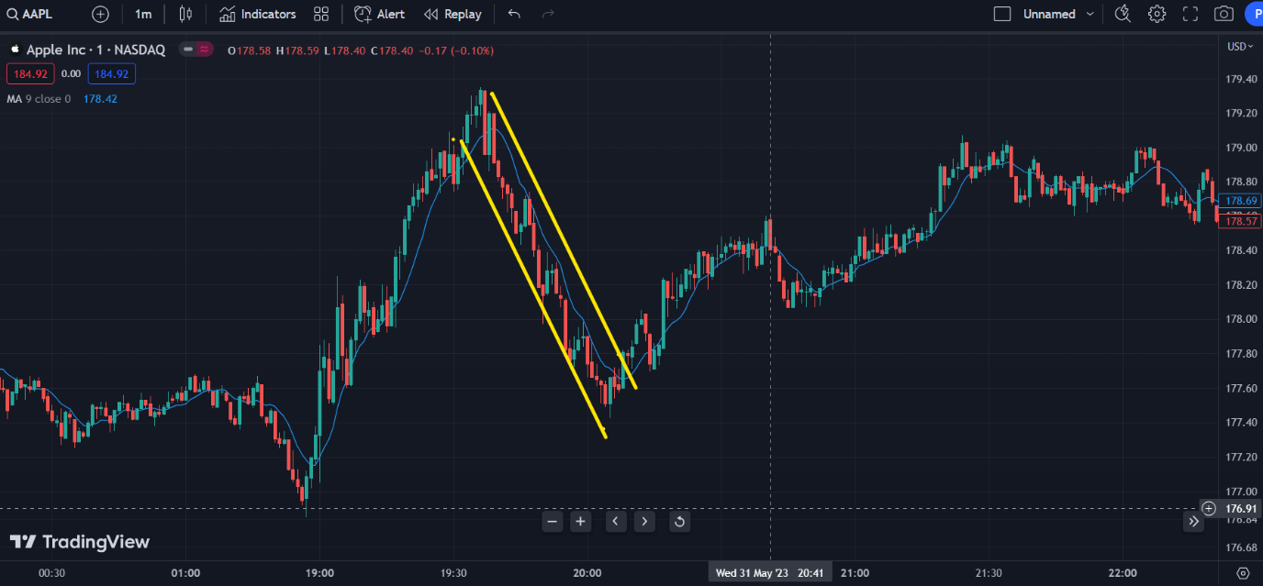

Cup and Holder

Timestamp -15-06-2023 23:30pm

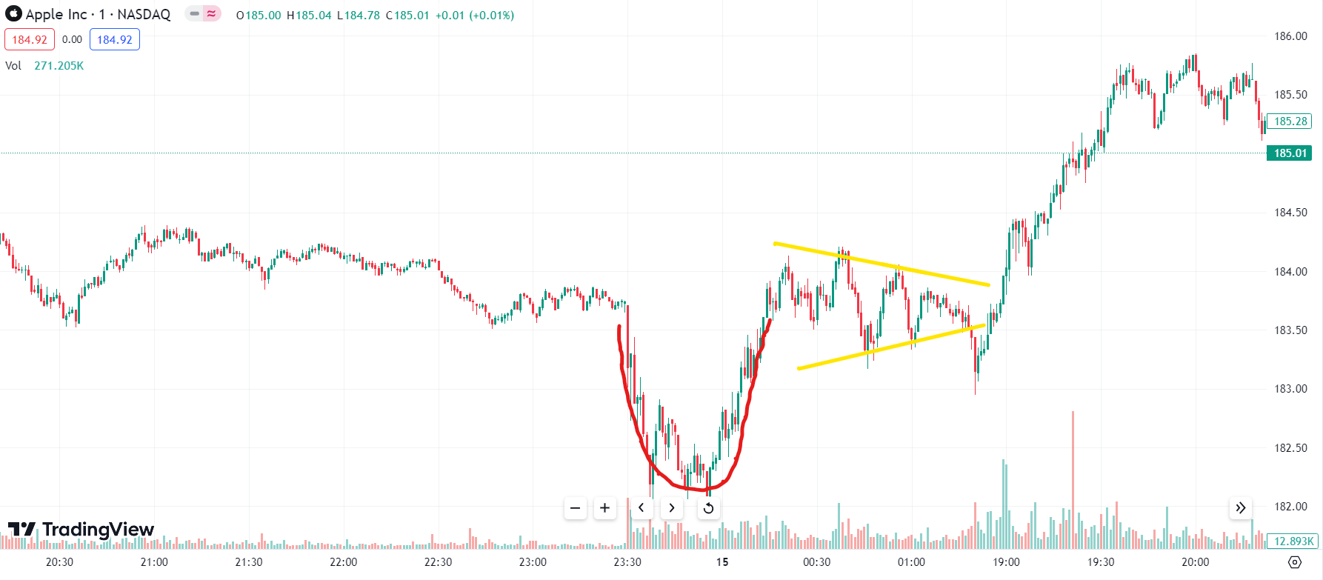

Head and Shoulder

Timestamp- 15-06-2023 21:00

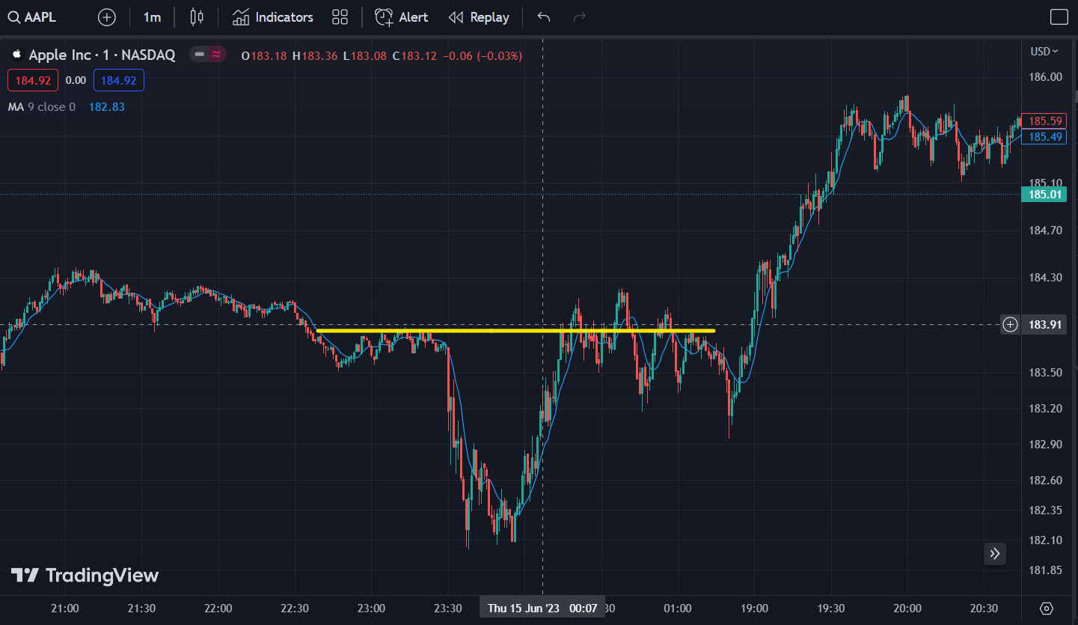

Rounding Top

Timestamp-10-01-2023 19:00pm

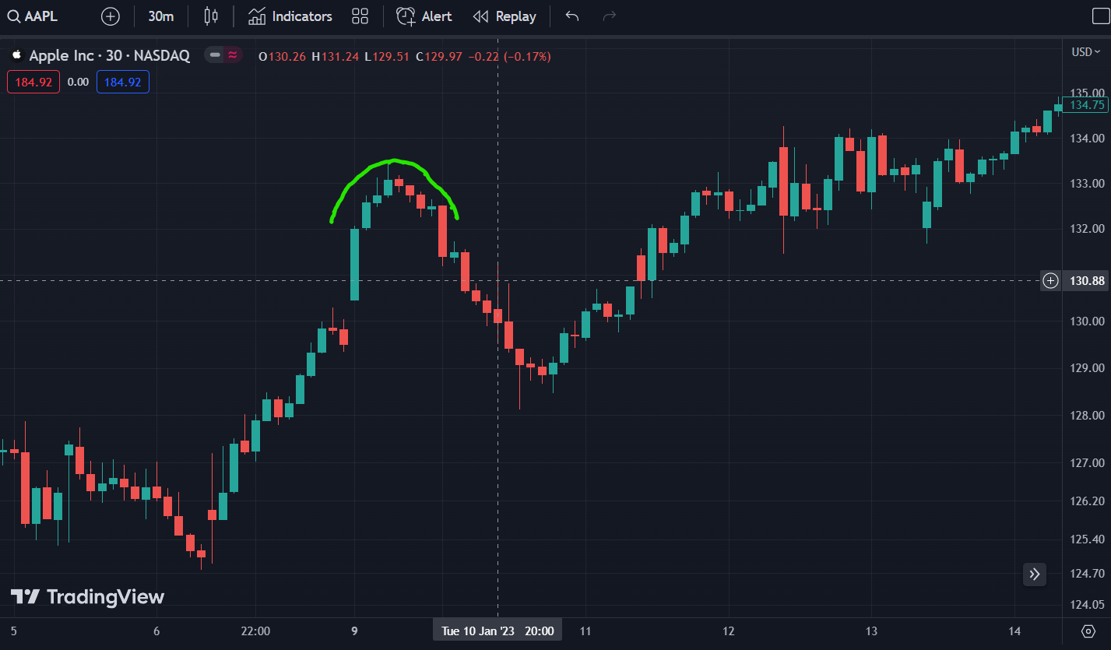

**Hindalco(NSE)**

Ascending Triangle

Timestamp- 19-05-2023 10:00a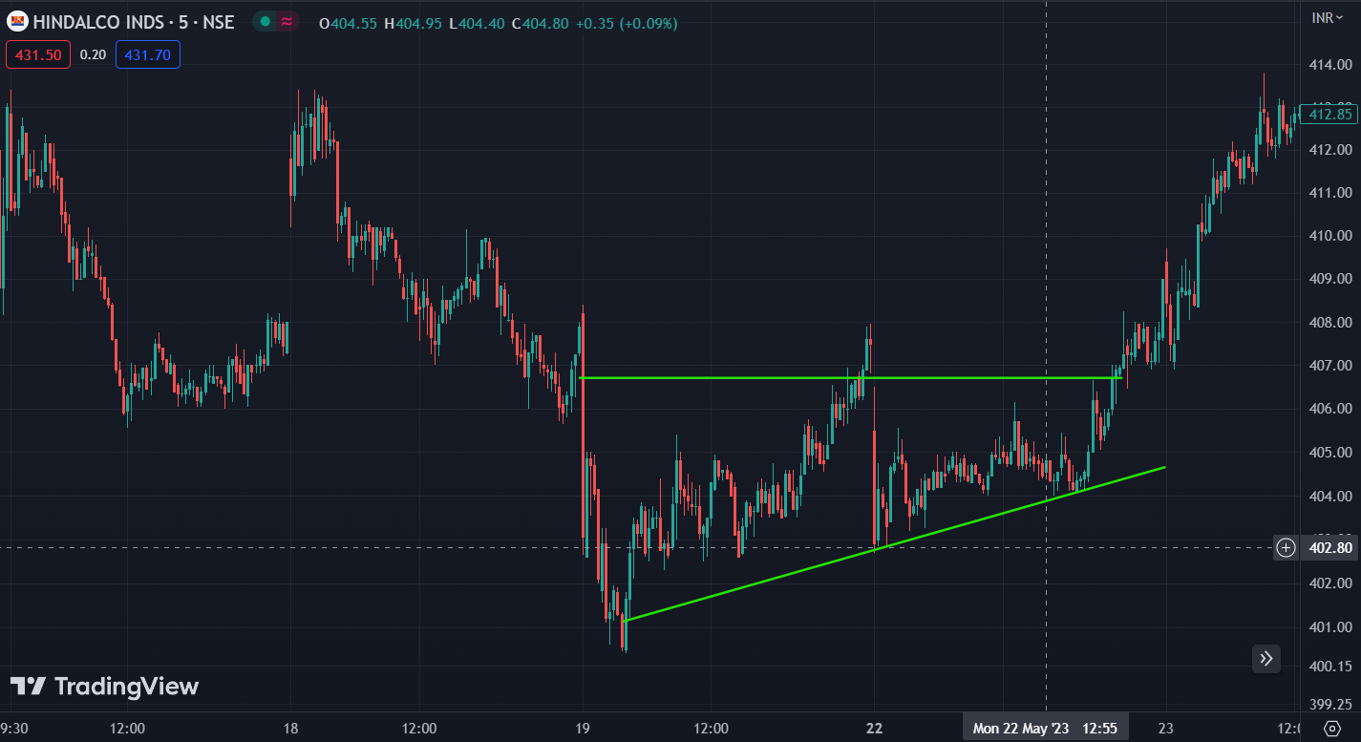

**Bearish Flag**

**Timestamp-15-06-2023 11:06am**

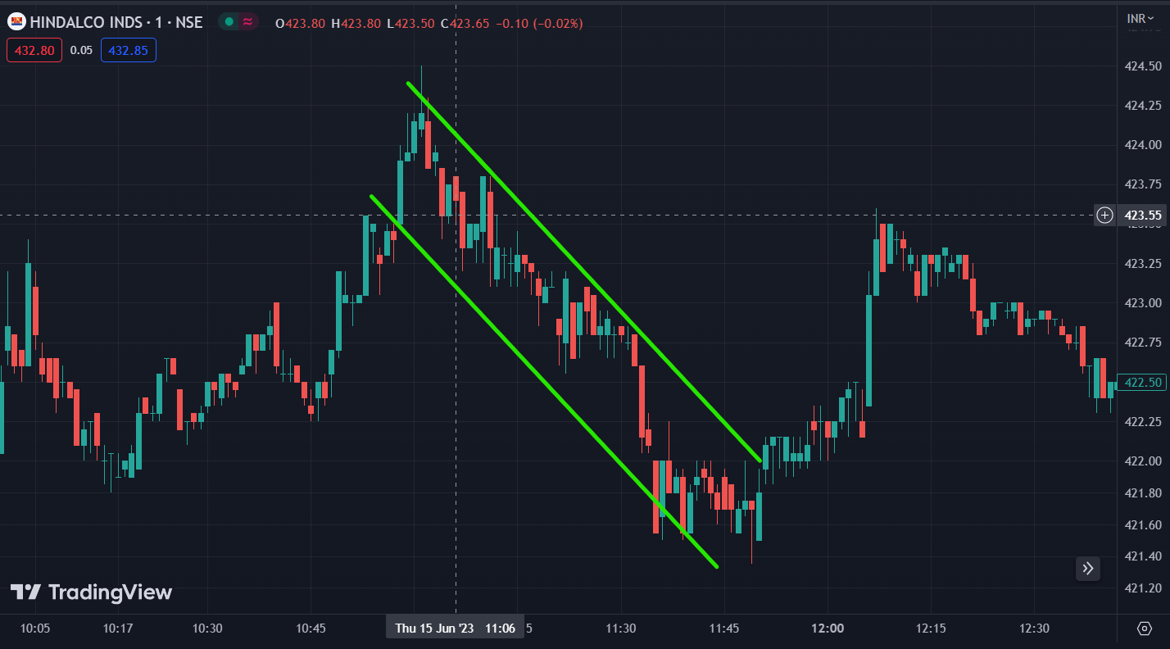

Cup And Holder Timestamp-25-04-2023 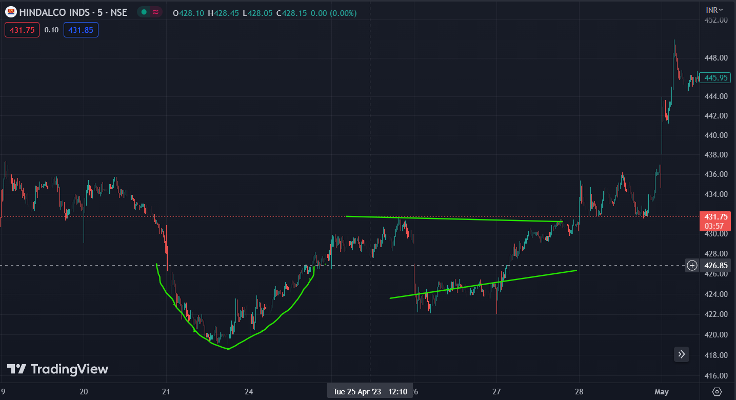

Head and shoulder Timestamp- 19-06-2023 14:00pm 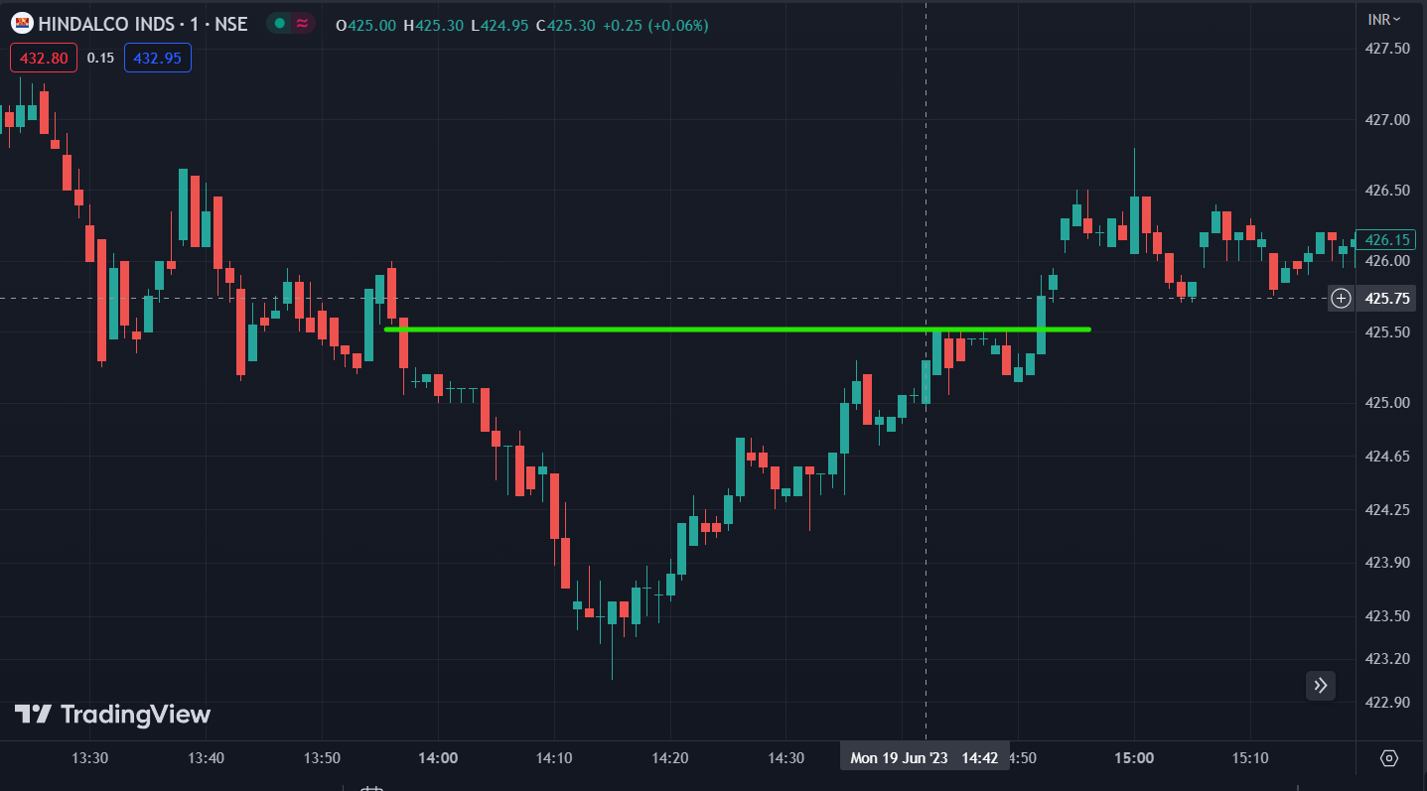 Rounding Top timestamp- 29-05-2023 9:40am 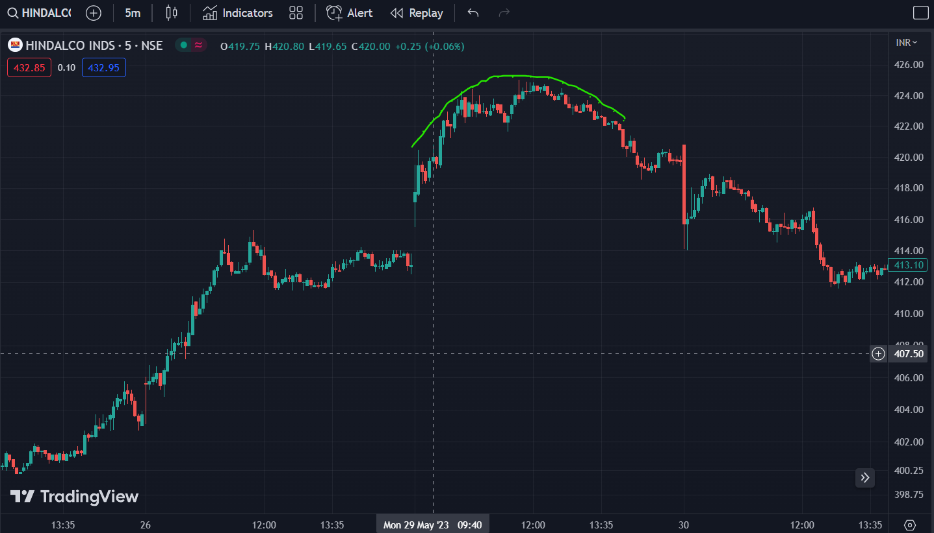

Microsoft(NASDAQ)

Ascending Triangle timestamp-14-06-2023 1900hrs 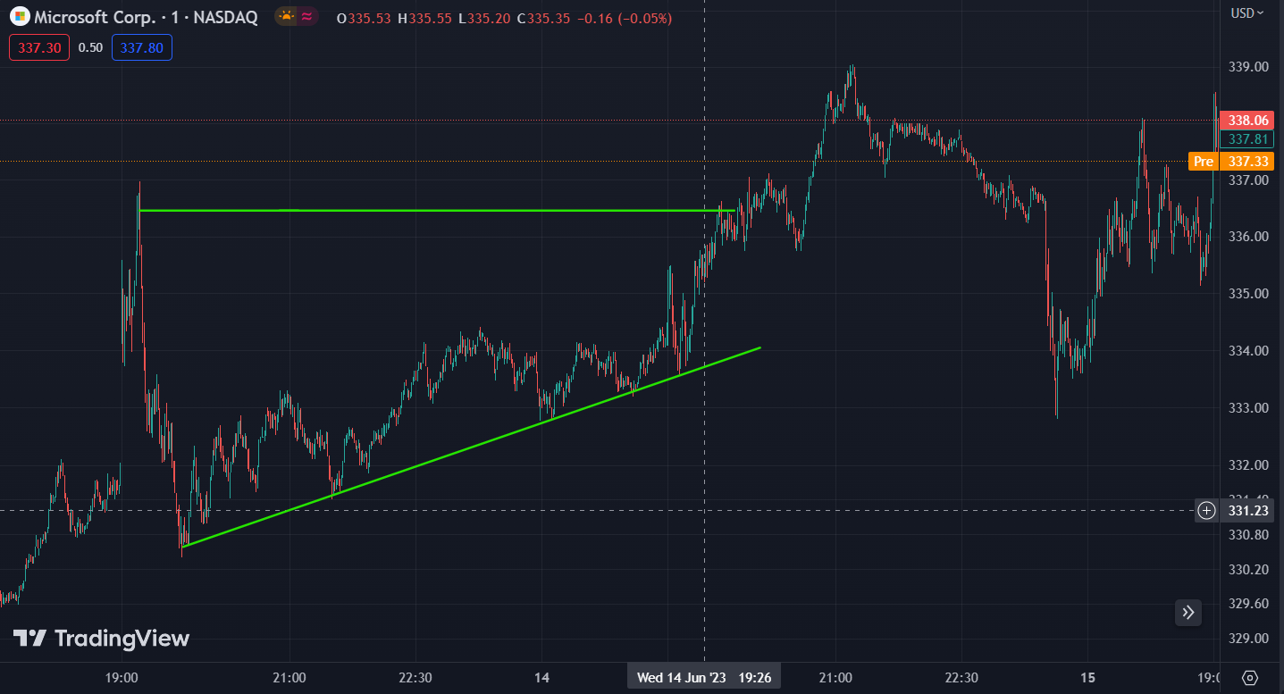 Bearish Flag timestamp 16-06-2023 19:10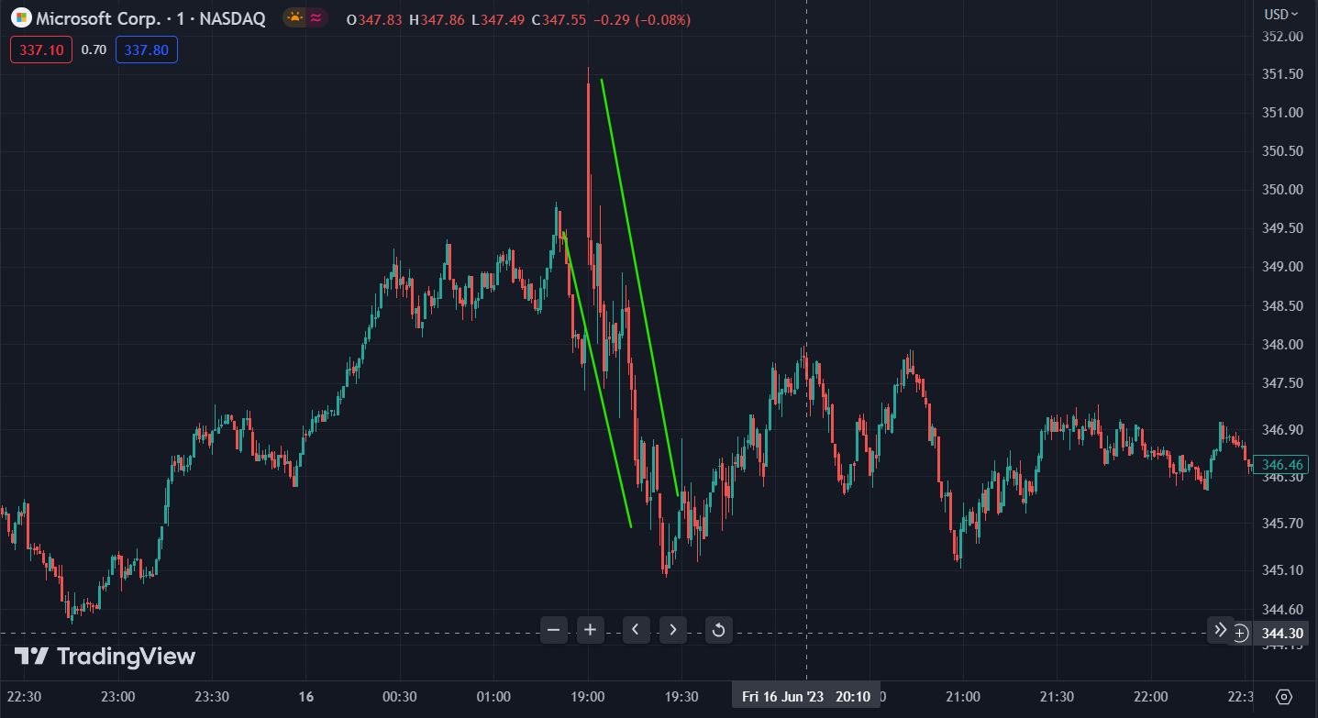

Cup and holder timestamp- 15-06-2023 23:30pm 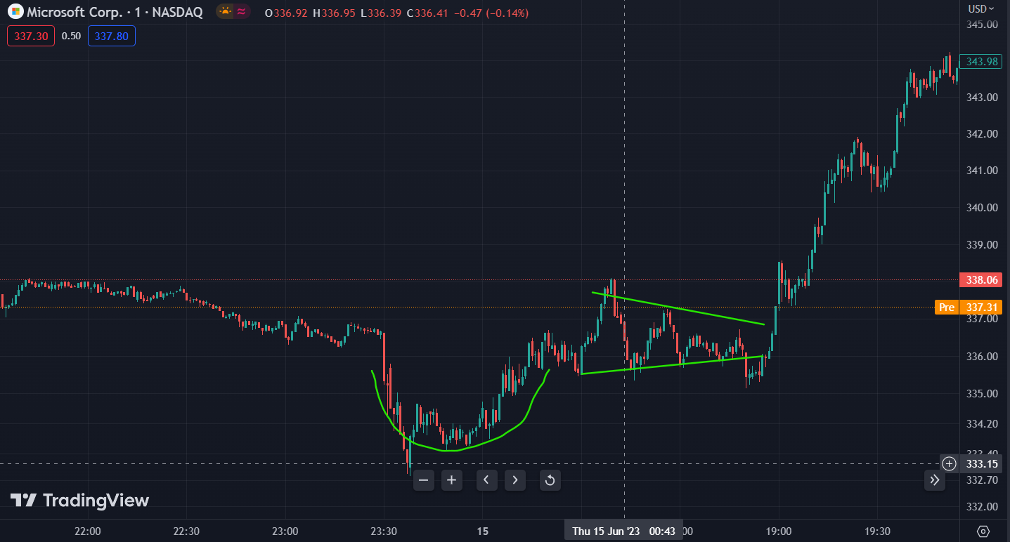 Head and shoulder timestamp- 9-06-2023 21:00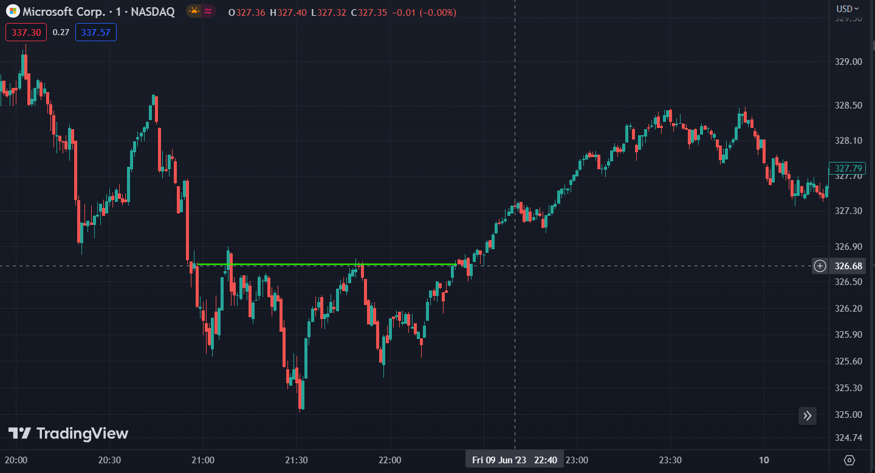

Rounding Top timestamp- 31-05-2023 19:15 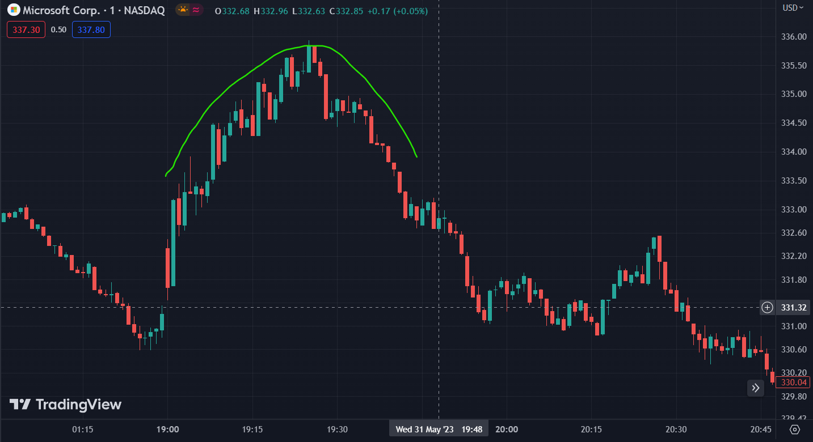

SunPharmaceutical(BSE)

Ascending Triangle timestamp- 9-06-2023 9:30am 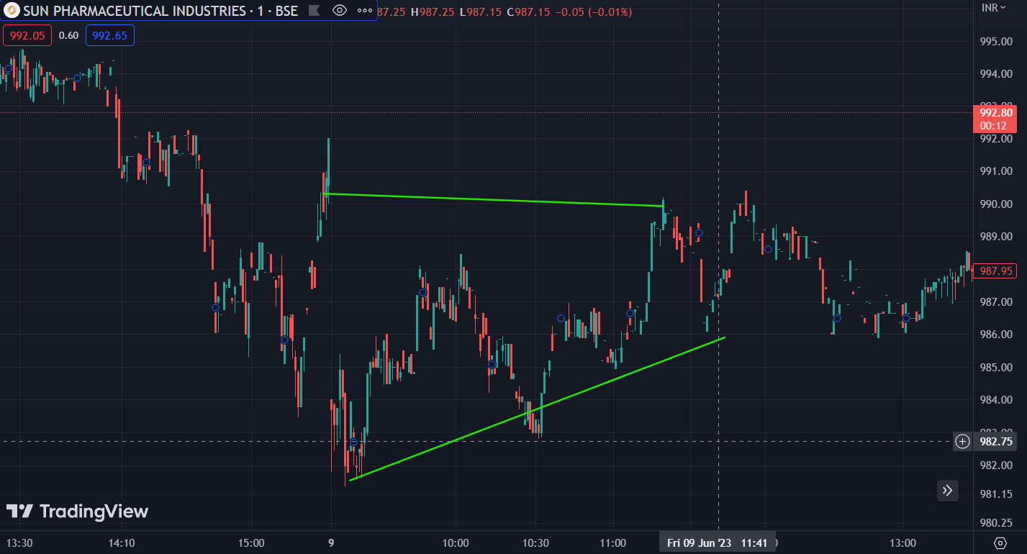

Bearish flag timestamp 31-05-2023 9:37am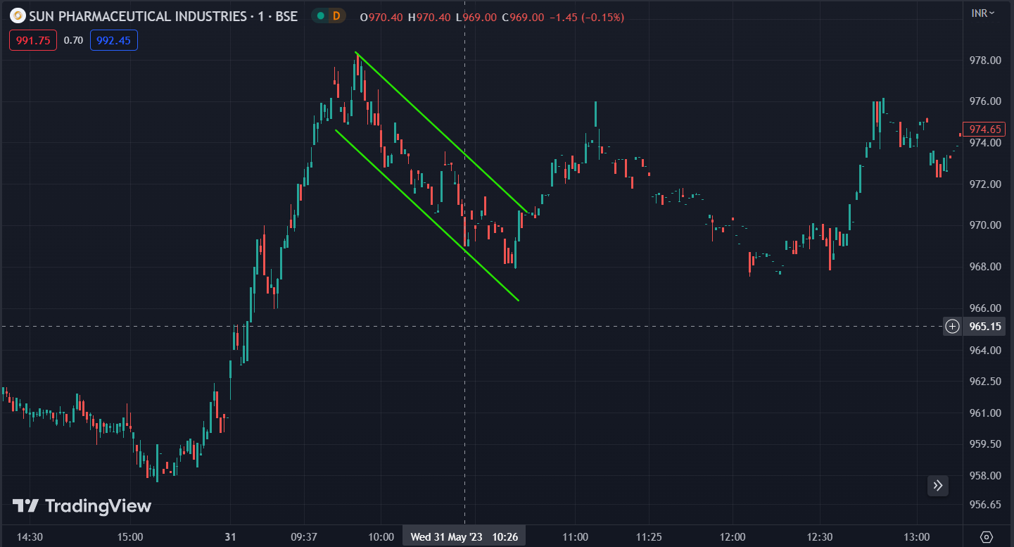

Cup and holder timestamp 18-05-2023 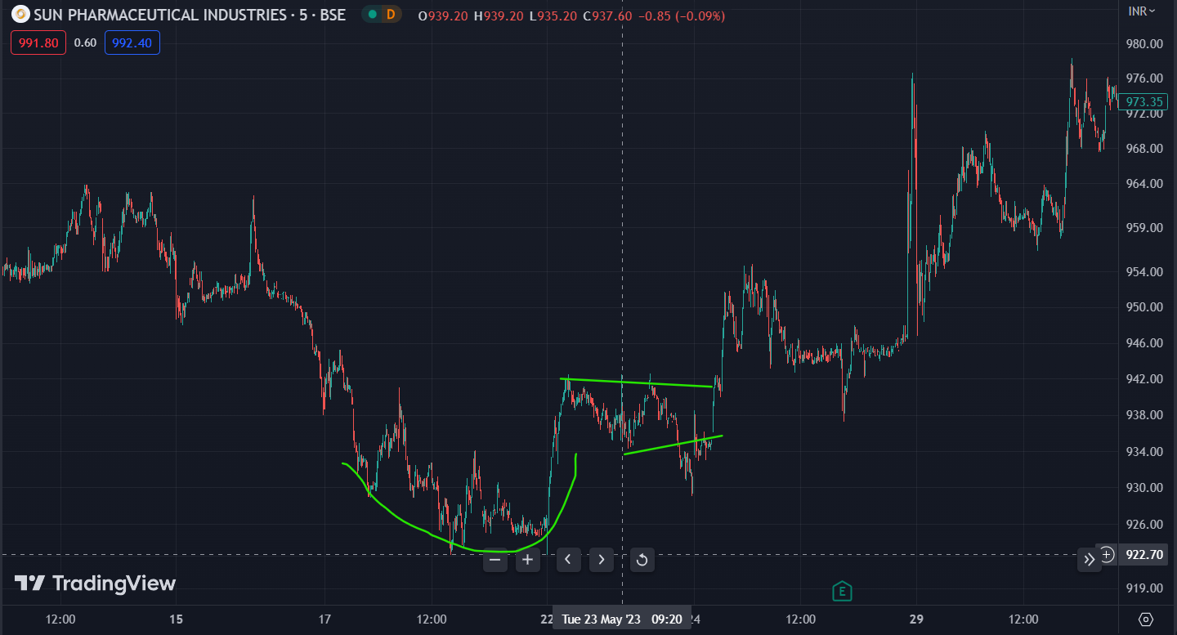

Head and shoulder 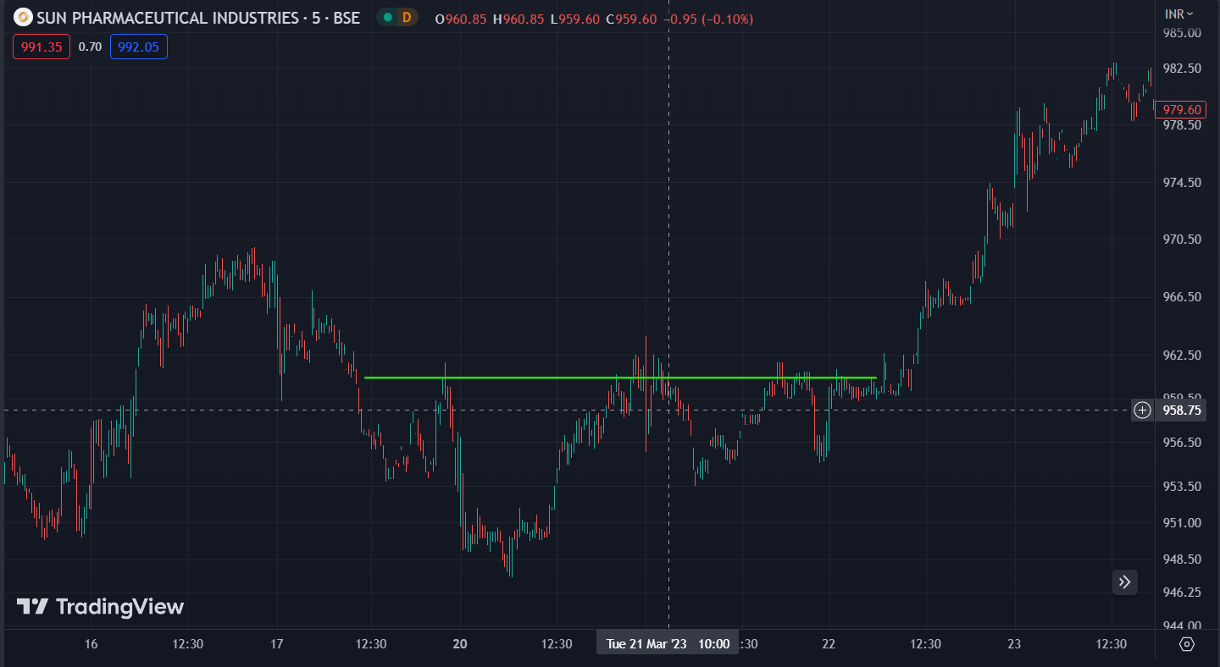 Rounding Top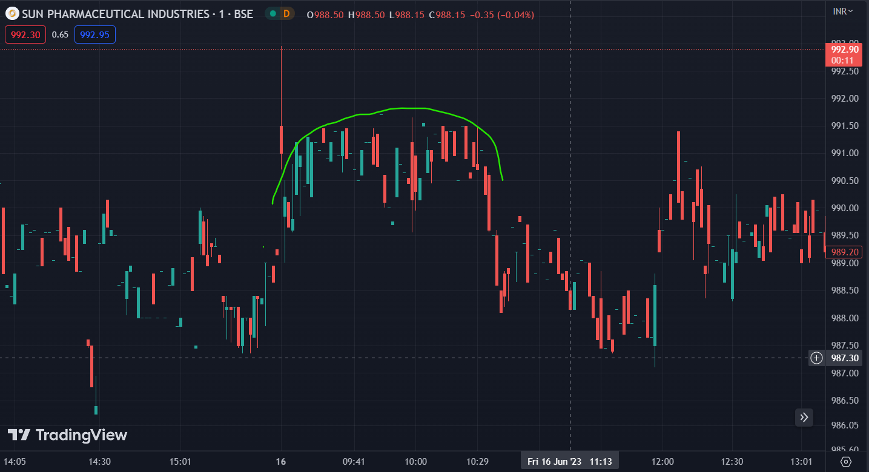 \

Tesla(NASDAQ) Ascending Triangle time stamp- 24-05-2023 21:00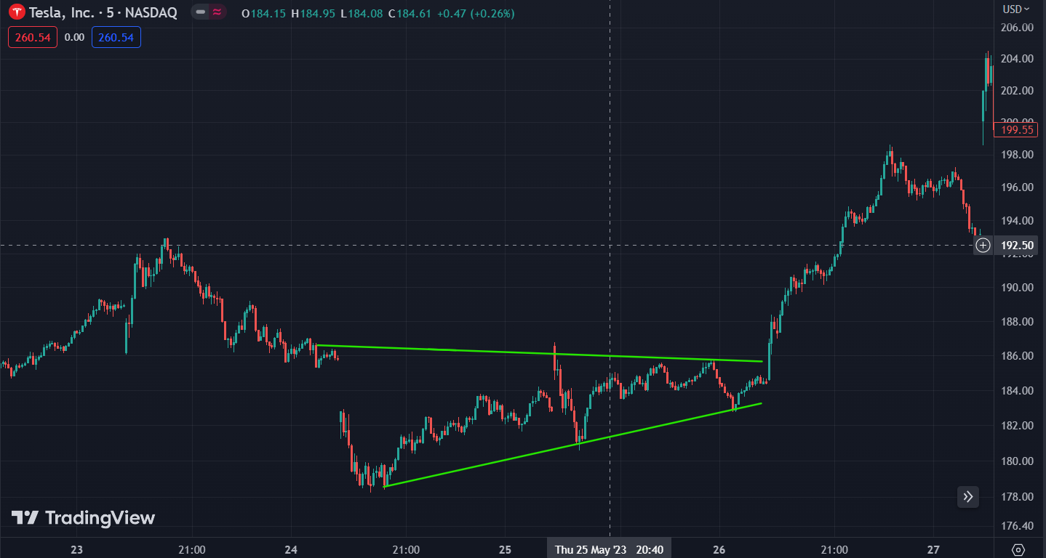 Bearish flag 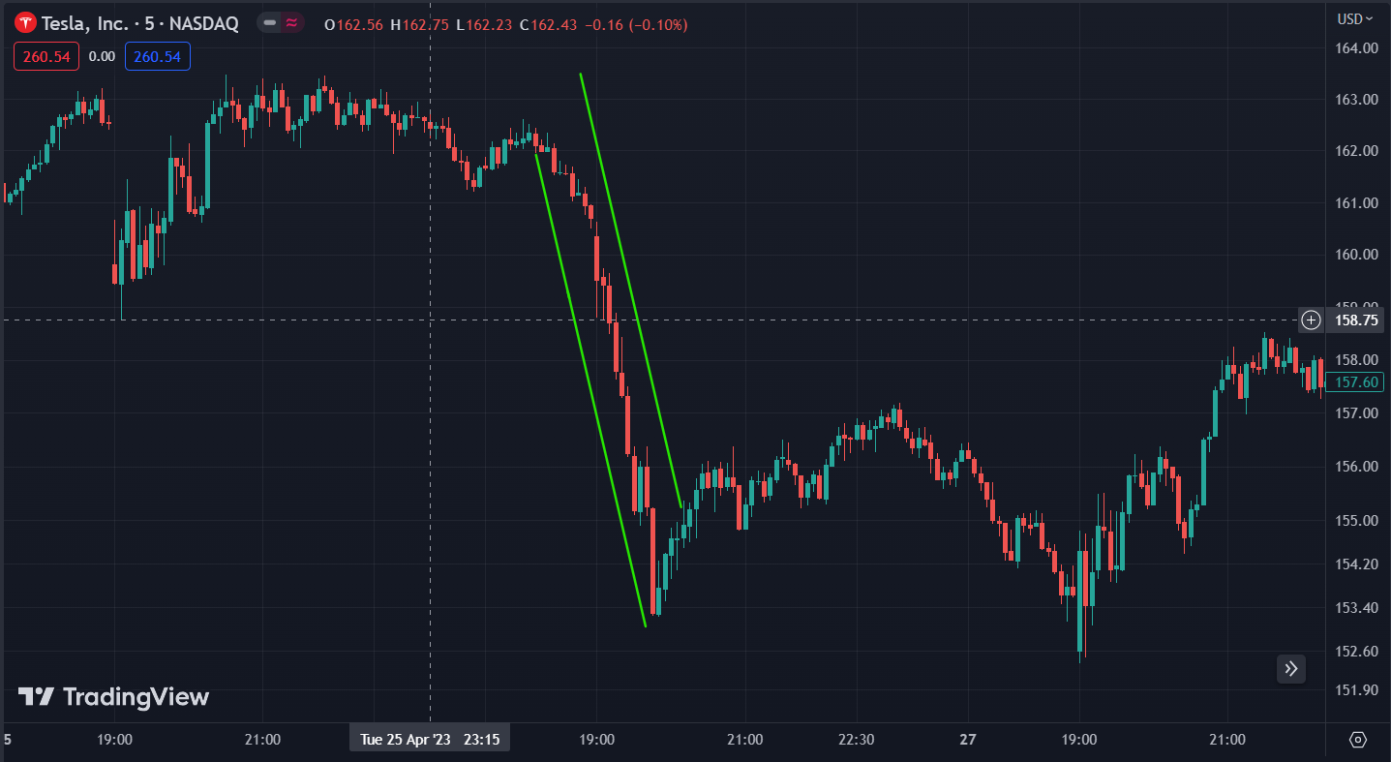

Cup and holder timestamp-6-06-2023 00:30am 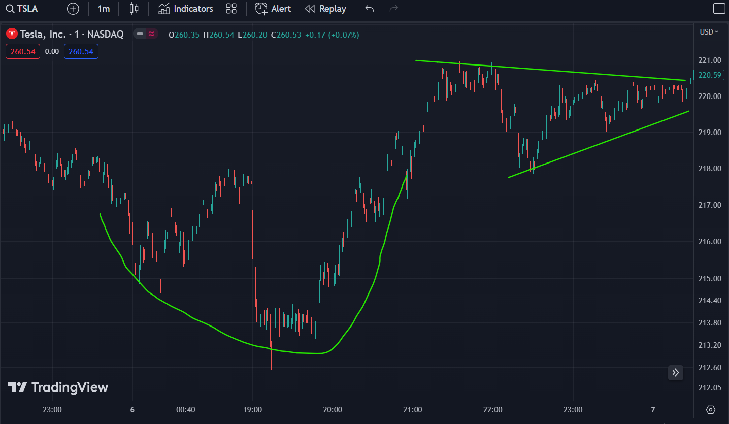

Head and shoulder timestamp 2-05-2023 21:00pm 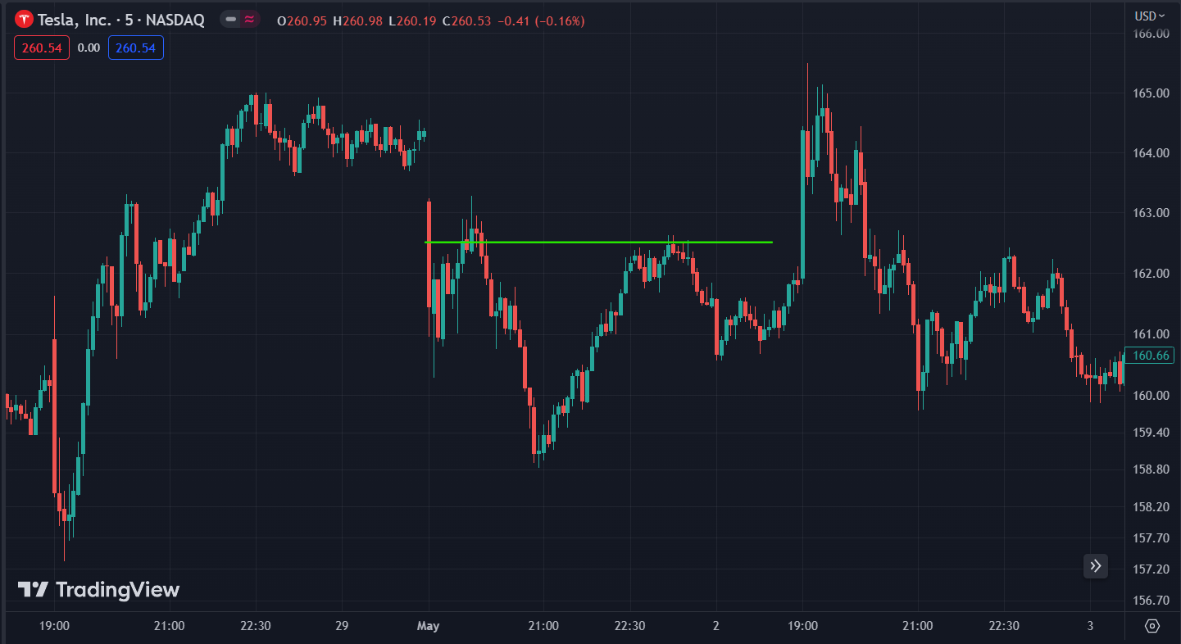

Rounding Top Timestamp 5-06-2023 2000hrs 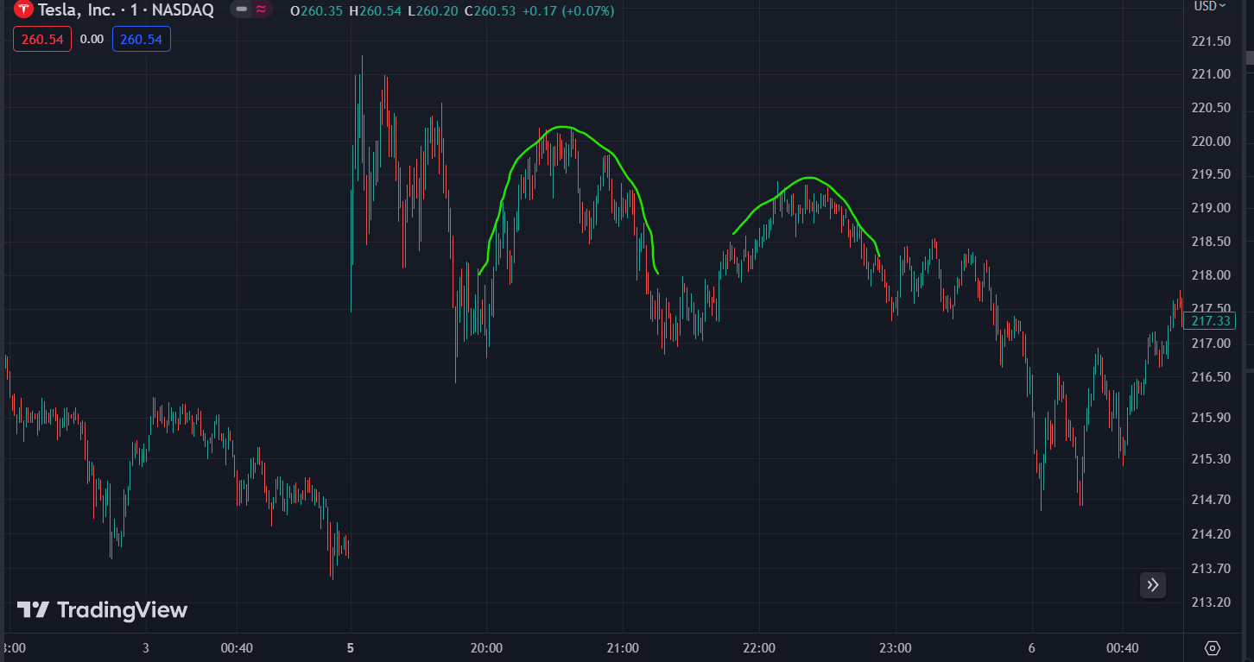

WALMART(NYSE) Ascending Triangle 7-06-2023 21:00pm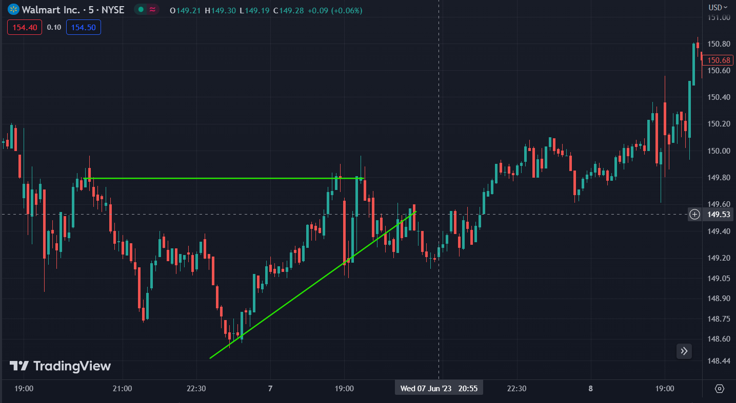

Bearish Flag timestamp 2-05-2023 19:30pm 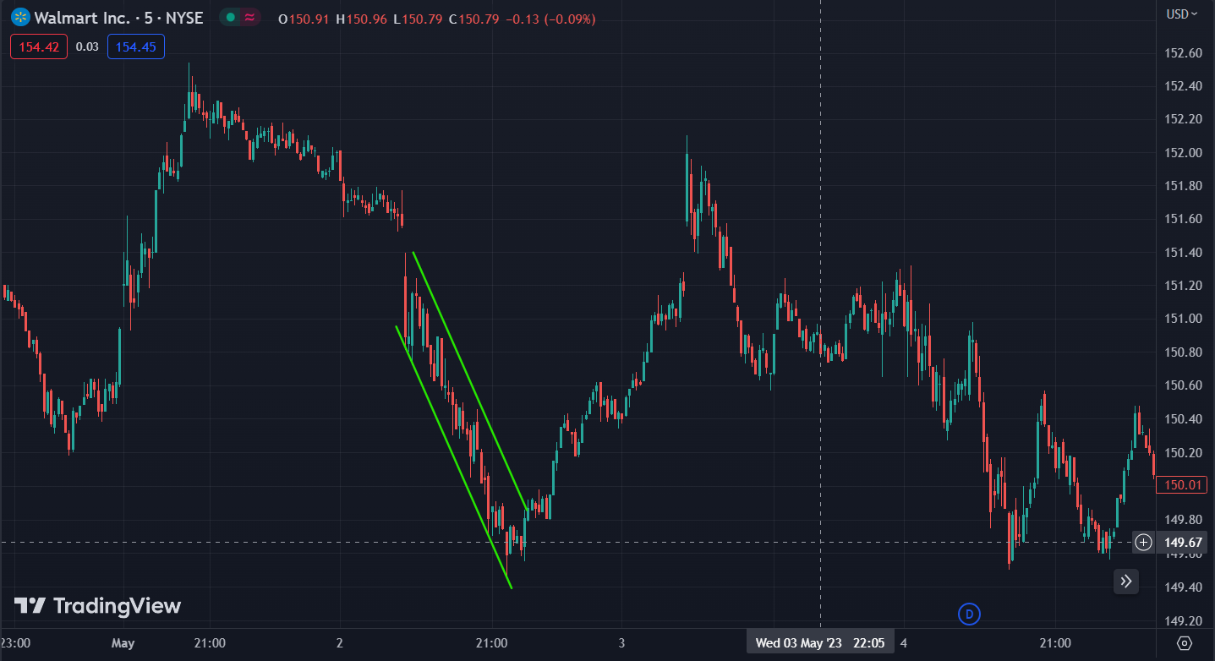

Cup and holder 11-05-2023 20:25pm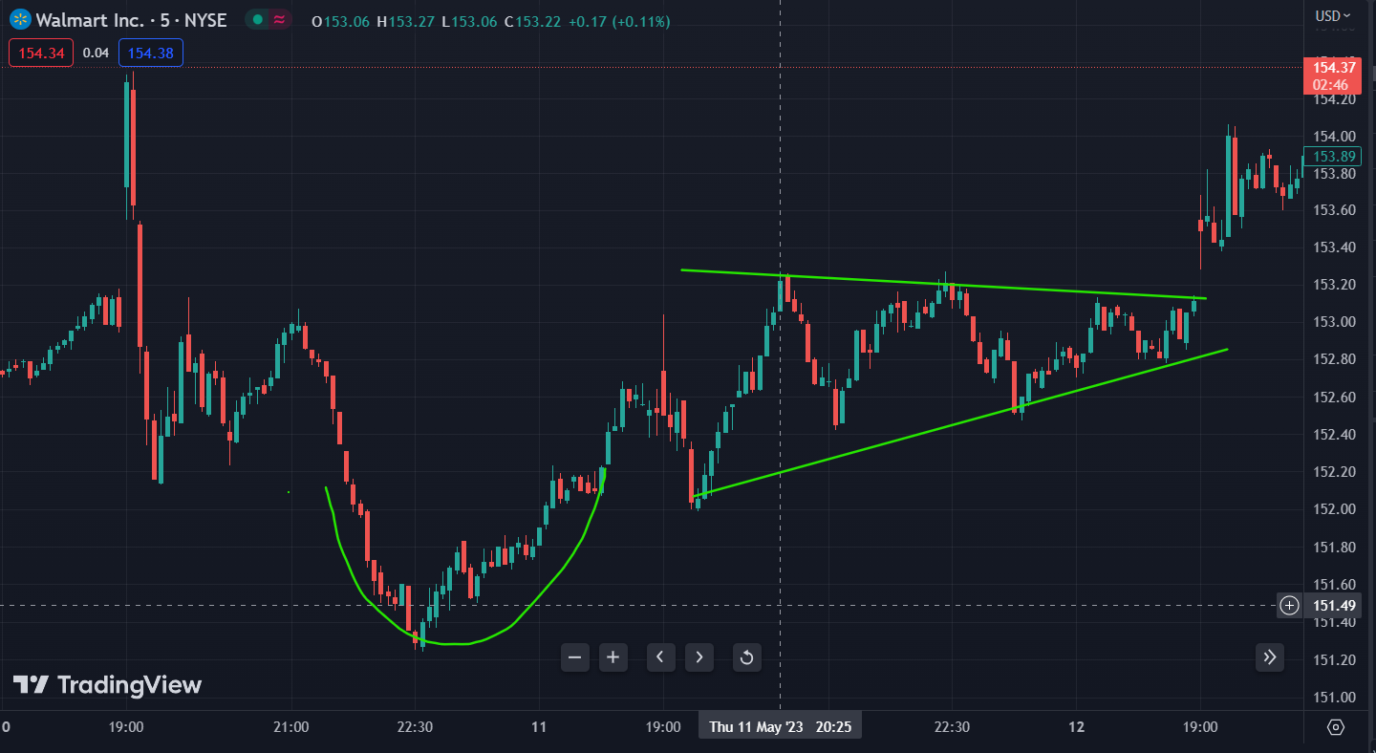

Head and shoulder time stamp 2-05-2023 20:05 pm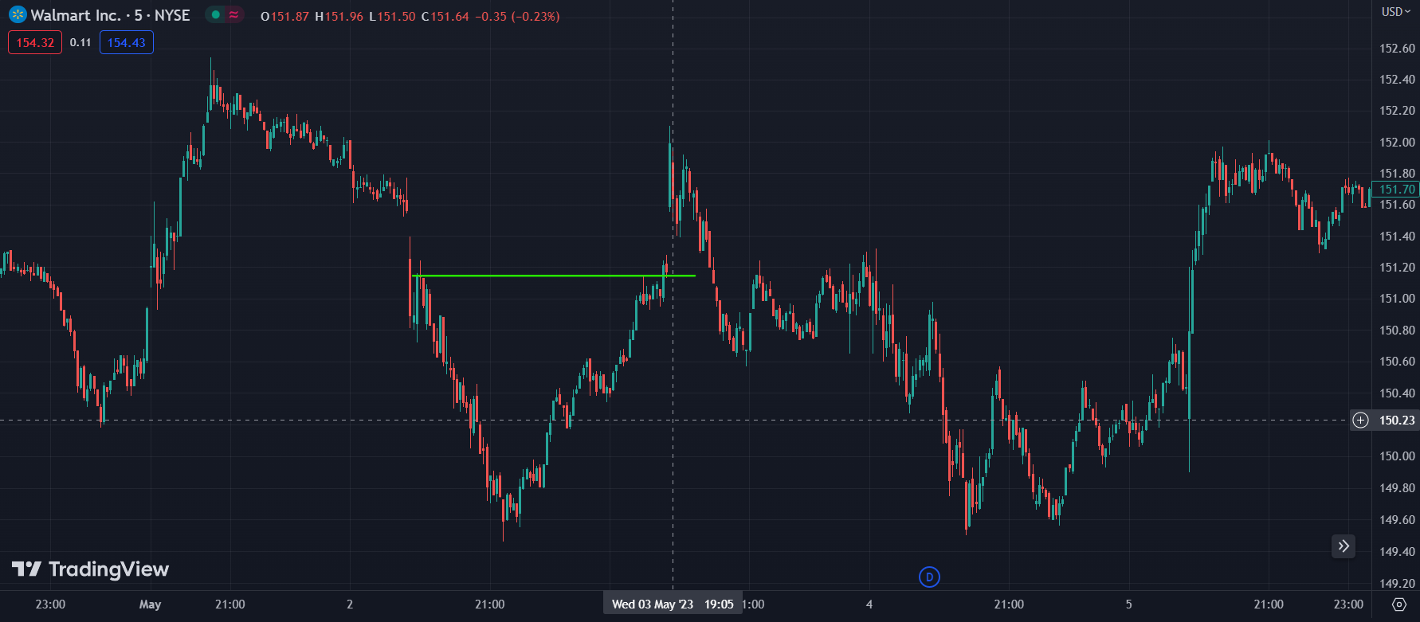

Rounding top Timestamp 11-04-2023 22:00pm

